**Sample 1**

**The pie chart shows the proportion of people from different households living in poverty in the UK in 2002. Write an analytical paragraph to describe the information in 100-120 words.**

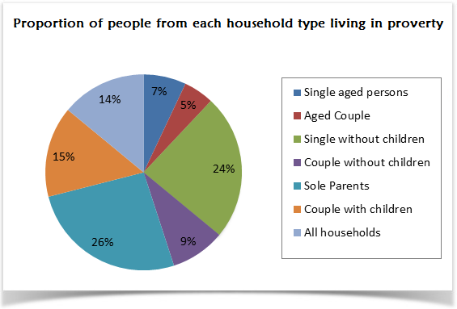

The given pie chart illustrates seven different categories of households living in poverty in the UK in 2002.

It is clearly evident from the pie chart that 26% of the total poverty-stricken households are those of sole parents. Single people without children account for the second highest proportion with 24%. In contrast to couples without children that accounts for just 9%, couples with children account for 15% of the poor households. Single aged persons and aged couples proportion for 12% together for poor households.

Overall, 14% of all households in the UK were living under poverty. The younger generation had a greater poor percentage than their aged counterparts. Couples without children had better economic conditions than those with children.

Sample 2

**The following table shows details about the internet activities for six categories for different age groups. Write an analytical paragraph for the table given in around 150-200 words.**

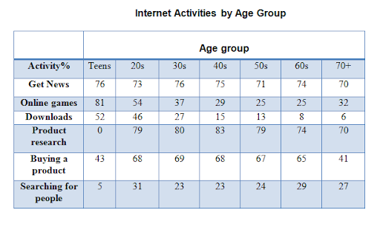

The given table suggests the internet activities of seven age groups ranging from teens to those in their seventies for six different kinds of activities. The table shows that the younger generation is more interested in online games and news, while the older generation spends time on the internet to research and buy products.

It is evident from the table that teens mainly use the internet for games (as high as 81%), news and downloads and are interested in searching for people or friends or doing any product research. The middle-age group (people in 20s to 60s) is highly interested in getting news, doing product research and buying products, the percentage ranging from 70-80%. The internet activity which gets the least time is searching for people. All the age groups spend less than 30% of their internet time on the same. The amount of time spent on downloads decreases with age and gets as low as 6% (for people in 70s).

Overall, the table suggests that teenagers are most likely to spend time playing games and doing downloads. On the other side, older people are interested in researching and buying products. People spend the least amount of time searching for other people online.